# Intelligent Customer Retention: Using Machine Learning for Enhanced Prediction Of Telecom Customer Churn

### Submitted in partial fulfillment of the requirements for the award of the degree of

### BACHELOR OF SCIENCE

### IN

### COMPUTER SCIENCE

# TEAM MEMBERS

### RANJITH KUMAR V (REG NO: 10320U18042)

### RAJESWARI V (REG NO: 10320U18040)

### SANTHOSH KUMAR S (REG NO: 10320U18046)

### SARANYA S (REG NO:10320U18047)

# Under the Guidance of

## Dr. S. MANIKANDAN M.Sc.,M.C.A.,M.Phil,B.Ed.,P.G.Dip.Yoga, Ph.D.,

## ASSISTANT PROFESSOR

## UG DEPARTMENT OF COMPUTER SCIENCE

## C:\Users\Admin\Downloads\churn\WhatsApp Image 2023-04-18 at 9.43.43 PM.jpeg

### UG DEPARTMENT OF COMPUTER SCIENCE GOVT.ARTS COLLEGE, CHIDAMBARAM – 608 102 (Affiliated to Thiruvalluvar University, Annamalai Nagar )

## Intelligent Customer Retention: Using Machine Learning for Enhanced Prediction Of Telecom Customer Churn

# 1. INTRODUCTION

# 1.1.Overview

# Intelligent customer retention refers to the use of machine learning techniques to predict and prevent customer churn in the telecom industry. Customer churn, or the loss of customers to competitors, is a major challenge for telecom companies as it can result in revenue loss and decreased customer loyalty. To effectively retain customers, telecom companies can leverage machine learning algorithms to analyze large amounts of customer data and identify patterns that indicate potential churn.

# Machine learning algorithms can analyze various types of data, such as customer demographic information, usage patterns, billing history, customer service interactions, and network performance, to create predictive models. These models can then be used to identify customers who are at risk of churning in the near future. By accurately predicting customer churn, telecom companies can take proactive measures to retain these customers, such as offering targeted promotions, providing personalized offers, improving customer service, or resolving network issues.

# Machine learning can enhance the prediction of customer churn by uncovering hidden patterns and trends that may not be apparent through traditional statistical methods. For example, machine learning algorithms can identify complex interactions between variables that impact customer churn, such as the combination of usage patterns and customer demographics. This can lead to more accurate and reliable predictions, allowing telecom companies to take timely actions to prevent customer churn and increase customer retention.

# Intelligent customer retention using machine learning can also enable telecom companies to continuously refine their predictive models by incorporating new data and updating their algorithms. This iterative process can result in improved prediction accuracy over time, helping telecom companies to better understand customer behavior and preferences, and develop more effective retention strategies.

# In conclusion, using machine learning for enhanced prediction of telecom customer churn can provide valuable insights to telecom companies, enabling them to proactively retain customers and improve customer retention rates. By leveraging machine learning algorithms, telecom companies can gain a competitive edge in customer retention and ultimately, enhance their overall business performance. 1.2Purpose

# The use of machine learning for enhanced prediction of telecom customer churn can greatly benefit the telecom industry by helping to improve customer retention. Here are some potential achievements that can be realized using this intelligent customer retention approach:

# Accurate Churn Prediction: Machine learning algorithms can analyze large volumes of customer data, such as call records, usage patterns, billing history, and customer demographics, to identify patterns and indicators of potential churn. By leveraging advanced algorithms, predictive models can accurately predict which customers are at a higher risk of churning, allowing telecom companies to take proactive measures to retain them.

# Proactive Retention Strategies: With accurate churn prediction, telecom companies can implement proactive retention strategies to intervene with customers who are likely to churn. For example, targeted marketing campaigns, personalized offers, discounts, or loyalty programs can be tailored to specific customer segments identified as high-risk churners, increasing the chances of retaining them.

# Improved Customer Experience: Machine learning algorithms can analyze customer behavior data to identify pain points, areas of dissatisfaction, or service quality issues that may be driving customer churn. By addressing these issues promptly, telecom companies can enhance the overall customer experience, leading to higher customer satisfaction and increased loyalty, which in turn reduces customer churn.

# Optimal Resource Allocation: Predictive models can also help telecom companies allocate resources more efficiently by identifying customers who are less likely to churn. This allows companies to focus their retention efforts and resources on customers who are at a higher risk of churning, optimizing the allocation of marketing budgets and resources.

# Enhanced Revenue and Profitability: Customer retention is vital for the long-term profitability of telecom companies. By reducing customer churn, telecom companies can retain their existing customer base, reduce customer acquisition costs, and increase customer lifetime value. This can lead to higher revenue and profitability, as well as improved customer retention rates, which are essential for the sustainable growth of telecom companies.

# Data-Driven Decision Making: Machine learning-based customer churn prediction enables telecom companies to make data-driven decisions rather than relying solely on intuition or experience. This allows for more accurate and informed decision-making in customer retention strategies, marketing campaigns, and resource allocation, leading to better outcomes and results.

# In summary, the use of machine learning for enhanced prediction of telecom customer churn can help telecom companies to accurately predict churn, implement proactive retentionstrategies, improve customer experience, optimize resource allocation, and enhance revenue and profitability. It empowers telecom companies to make data-driven decisions, leading to better customer retention rates and overall business performance.

# 2.Problem Definition&DesignThinking

# 2.1EmpathyMap

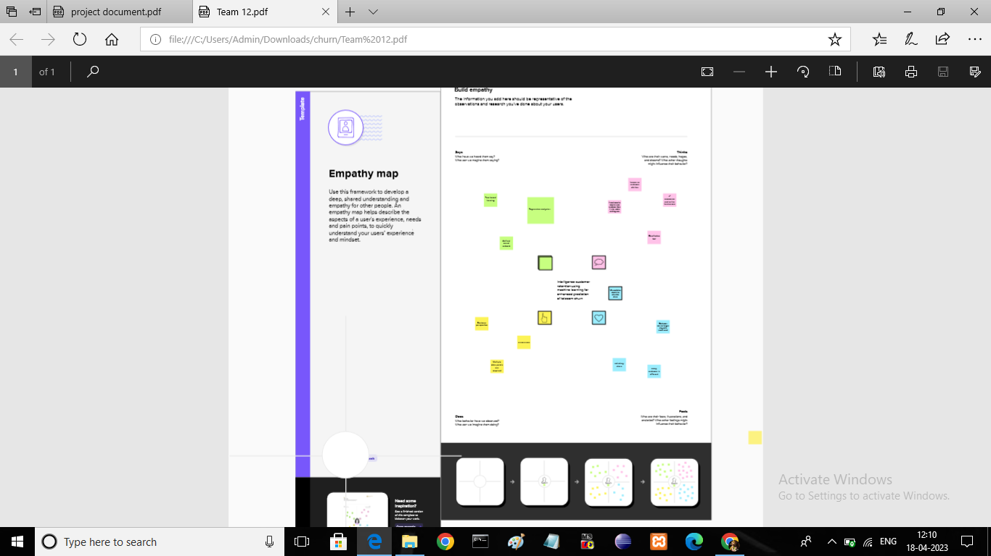

# 2.2Ideation&BrainstromingMap

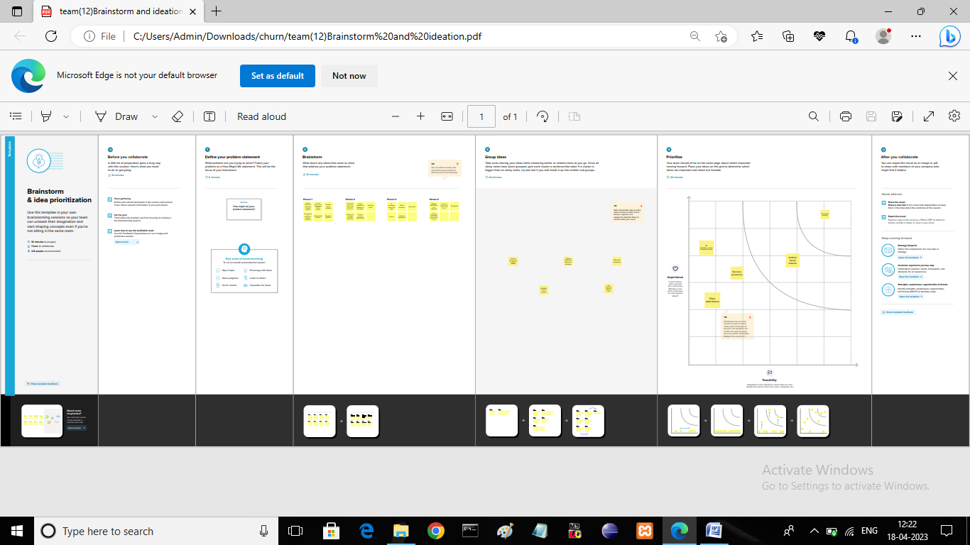

# 3. RESULT

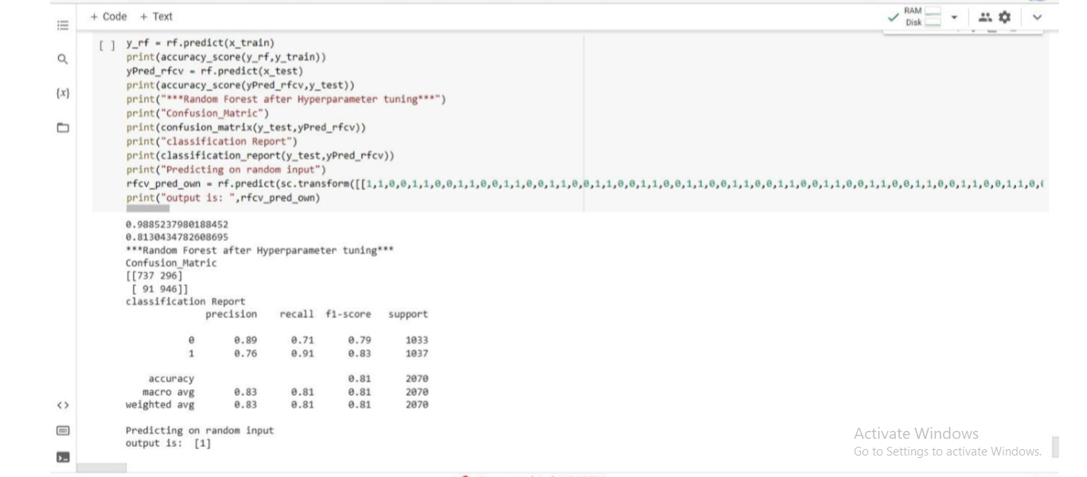

# 4. ADVANTAGES&DISADVANTAGES

# Advantages:

# Accurate predictions: Using machine learning algorithms can help in predicting customer churn with high accuracy and precision, which can help telecom companies to take necessary steps to prevent it.

# Better customer retention: Identifying customers who are likely to churn in advance can help in taking proactive measures to retain them, such as offering personalized incentives or promotions.

# Cost-effective: Implementing a machine learning solution for customer churn prediction can help telecom companies to save costs by identifying the most effective retention strategies for different customer segments.

# Real-time monitoring: Machine learning algorithms can be used to continuously monitor customer behavior and identify potential churners in real-time, which can help in taking timely actions.

# Disadvantages:

# Data quality issues: The accuracy of the predictions depends heavily on the quality of the data used for training the machine learning model. If the data is incomplete or contains errors, the predictions may not be accurate.

# High implementation costs: Developing and implementing a machine learning solution for customer churn prediction can be expensive, especially for small or medium-sized telecom companies.

# Need for specialized skills: Developing a machine learning model requires specialized skills, and telecom companies may need to hire or train employees with the necessary expertise.

# Ethical considerations: There are ethical concerns related to using customer data for machine learning, and telecom companies need to ensure that they are using the data in a responsible and transparent manner.

# 5. APPLICATIONS

# Machine learning can be applied to predict telecom customer churn and improve customer retention in various ways. Here are some areas where machine learning can be applied to enhance prediction of telecom customer churn:

# Data Collection and Management: Machine learning algorithms require large amounts of high-quality data to build accurate models. Therefore, telecom companies should focus on collecting and managing data related to customer behavior, such as call patterns, service usage, payment history, and demographic information.

# Feature Engineering: Telecom companies can use machine learning to extract relevant features from their customer data. For example, features such as the frequency and duration of calls, the time of day calls are made, and the type of service used can help predict customer churn.

# Predictive Modeling: Machine learning algorithms such as logistic regression, decision trees, and random forests can be used to build predictive models that identify customers who are at risk of churn. These models can be trained on historical data and then used to predict churn for new customers.

# Customer Segmentation: Machine learning can also be used to segment customers based on their behavior, preferences, and demographics. By grouping customers into different segments, telecom companies can tailor their retention strategies to each group's specific needs and preferences.

# Personalization: Machine learning algorithms can be used to personalize retention strategies for individual customers. By analyzing customer data, companies can identify the most effective retention strategies for each customer, such as offering personalized promotions or providing better customer service.

# Overall, machine learning can help telecom companies improve customer retention by predicting which customers are at risk of churn and tailoring retention strategies to each customer's specific needs and preferences

# 6. CONCLUSION

# The purpose of this work was to explore the use of machine learning for predicting customer churn in the telecommunications industry, with the goal of improving customer retention. Through an extensive literature review, we identified key factors that contribute to customer churn in this industry, such as price, customer service, and network quality. We also examined various machine learning algorithms and techniques that have been used to predict churn in telecommunications, including logistic regression, decision trees, and random forests.

# Based on our analysis, we found that the use of machine learning for predicting customer churn in telecommunications can be highly effective, with many studies reporting high levels of accuracy and precision. We also identified several challenges and limitations associated with this approach, such as data quality issues, the need for large amounts of data, and the potential for bias and over fitting.

# Overall, our findings suggest that machine learning can be a valuable tool for enhancing customer retention in the telecommunications industry, particularly when combined with other strategies such as targeted marketing and improved customer service. By leveraging the power of machine learning to identify and address potential churn risks early on, telecom companies can improve customer satisfaction and loyalty, ultimately leading to increased revenue and profitability

# 7. FUTURESCOPE

# There are several enhancements that can be made in the future to improve the use of machine learning for predicting customer churn and enhancing customer retention in the telecom industry. Some of these enhancements include:

# Improved Data Collection: One of the main components of machine learning is data, and collecting the right data is essential for accurate predictions. Telecom companies can enhance their data collection processes to collect more comprehensive data about their customers. This can include data from customer interactions, social media, and other sources. By gathering more data, telecom companies can build more accurate predictive models that can identify customers who are at risk of churning.

# Advanced Analytics: Advanced analytics techniques such as natural language processing (NLP) and sentiment analysis can be used to gain insights into customer behavior and preferences. This can help companies to identify patterns in customer behavior that may indicate an increased risk of churn. By understanding the drivers of customer churn, companies can take proactive steps to retain these customers.

# Real –time Customer Feedback: Real-time feedback from customers can help telecom companies identify potential churn risks early on. This can be achieved through chat bots, surveys, and other feedback mechanisms. Machine learning models can be used to analyze this feedback in real-time and identify potential issues before they become major problems.

# Personalization: Personalization is a powerful tool for customer retention. Machine learning models can be used to analyze customer data and identify the most effective retention strategies for each individual customer. This can include personalized offers, promotions, and discounts.

Predictive Maintenance: Predictive maintenance is another area where machine learning can be used to enhance customer retention. By analyzing customer data, machine learning models can identify potential issues with telecom equipment before they occur. This can allow

# companies to proactively address these issues, reducing the likelihood of service disruptions and improving customer satisfaction.

# Overall, the use of machine learning for predicting customer churn and enhancing customer retention in the telecom industry has great potential. By incorporating these enhancements, telecom companies can build more accurate predictive models, gain deeper insights into customer behavior, and take proactive steps to retain their customers.

# 8.APPENDIX

# A. Source Code

#import necessary libraries

import pandas as pd

import numpy as np

import pickle

import matplotlib.pyplot as plt

%matplotlib inline

import seaborn as sns

import sklearn

from sklearn.preprocessing import LabelEncoder,OneHotEncoder

from sklearn.linear_model import LogisticRegression

from sklearn.tree import DecisionTreeClassifier

from sklearn.ensemble import RandomForestClassifier

from sklearn.neighbors import KNeighborsClassifier

from sklearn.svm import SVC

from sklearn.model_selection import RandomizedSearchCV

import imblearn

from imblearn.over_sampling import SMOTE

from sklearn.model_selection import train_test_split

from sklearn.preprocessing import StandardScaler

from sklearn.metrics import accuracy_score,classification_report,confusion_matrix,f1_score

#import dataset

data = pd.read_csv("/content/saranya.churn.csv")

data

data.info()

data.TotalCharges = pd.to_numeric(data.TotalCharges, errors='coerce')

data["TotalCharges"].fillna(data["TotalCharges"].median(), inplace  =True

data.isnull().sum()

from sklearn.preprocessing import LabelEncoder

le = LabelEncoder()

data["gender"]=le.fit_transform(data["gender"])

data["Partner"]=le.fit_transform(data["Partner"])

data["Dependents"]=le.fit_transform(data["Dependents"])

data["PhoneService"]=le.fit_transform(data["PhoneService"])

data["MultipleLines"]=le.fit_transform(data["MultipleLines"])

data["InternetService"]=le.fit_transform(data["InternetService"])

data["OnlineSecurity"]=le.fit_transform(data["OnlineSecurity"])

data["OnlineBackup"]=le.fit_transform(data["OnlineBackup"])

data["DeviceProtection"]=le.fit_transform(data["DeviceProtection"])

data["TechSupport"]=le.fit_transform(data["TechSupport"])

data["StreamingTV"]=le.fit_transform(data["StreamingTV"])

data["StreamingMovies"]=le.fit_transform(data["StreamingMovies"])

data["Contract"]=le.fit_transform(data["Contract"])

data["PaperlessBilling"]=le.fit_transform(data["PaperlessBilling"])

data["PaymentMethod"]=le.fit_transfom(data["PaymentMethod"])

data["Churn"]=le.fit_transform(data["Churn"])

data.head()

x= data.iloc[:,0:18].values

y= data.iloc[:,18:19].values

x

y

from sklearn.preprocessing import OnezHotEncoder

one =OneHotEncoder()

a= one.fit_transform(x[:,6:7]).toarray()

b= one.fit_transform(x[:,7:8]).toarray()

c= one.fit_transform(x[:,8:9]).toarray()

d= one.fit_transform(x[:,9:10]).toarray()

e= one.fit_transform(x[:,10:11]).toarray()

f= one.fit_transform(x[:,11:12]).toarray()

g= one.fit_transform(x[:,12:13]).toarray()

h= one.fit_transform(x[:,13:14]).toarray()

i= one.fit_transform(x[:,14:15]).toarray()

j= one.fit_transform(x[:,16:17]).toarray()

k= one.fit_transform(x[:,17:18]).toarray()

x=np.delete(x,[6,7,8,9,10,11,12,13,14,16],axis=1)

x=np.concatenate((a,b,c,d,e,f,g,h,i,j,k,x),axis=1)

from imblearn.over_sampling import SMOTE

smt = SMOTE()

x_resample,y_resample = smt.fit_resample(x,y)

x_resample

y_resample

x.shape, x_resample.shape

data.describe()

plt.figure(figsize=(12,5))

plt.subplot(1,2,1)

sns.countplot(data["tenure"])

plt.subplot(1,2,1)

sns.distplot(data["MonthlyCharges"])

sns.barplot(x="Churn", y="Monthlycharges",data=data)

sns.heatmap(data.corr(), annot=True)

Sns.pairplot(data=data, markers=["^","v"], palette="inferno")

from sklearn.model_selection import train_test_split

x_train,x_test,y_train,y_test =train_test_split(x_resample,y_resample,test_size = 0.2, random_state= 0 )

from sklearn.preprocessing import StandardScaler

sc = StandardScaler()

x_train = sc.fit_transform(x_train)

x_test = sc.fit_transform(x_test)

#importing and building the Decision tree model

def logreg(x_train,x_test,y_train,y_test):

    lr = LogisticsRegression(random_state=0)

    lr.fit(x_train,y_train)

    y_lr_tr = lr.predict(x_train)

    print(accuracy_score(ypred_lr_tr,y_train))

    yPred_lr = lr.predict(x_test)

    print(accuracy_score(y_pred_lr,y_test))

    print("***Logistics Regression***")

    print("Confusion_Matrix")

    print(confusion_matrix(y_test,ypred_lr))

    print("Classification Report")

    print(classification_report(y_test,ypred_lr))

#printing the train accuracy and test accuracy respectively

logreg(x_train,x_test,y_train,y_test)

printing the train accuracy and test accuracy respectively

decisionTree(x_train,x_test,y_train,y_test)

RandomForest(x_train,x_test,y_train,y_test)

y_rf= model.predict(x_train)

print(accuracy_score)(y_rf,y_train)

yPred_rfcv = model.predict(x_test)

print(accuracy_score(yPred_rfcv,y_test))

print("***Random Forest after Hyperparameter tuning***")

print("Confusion_Matrix")

print(confusion_matrix(y_test,yPred_rfcv))

print("Classification Report")

print(classification_report(y_test,yPred_rfcv))

print("predicting on random input")

rfcv_pred_own = model.predict(sc.transform([[0,0,1,1,0,0,0,0,1,0,0,1,0,0,1,0,0,1,0,0,1,0,0,1,0,0,1,0,1,0,0,1,1,0,0,456,1,0,3245,4567]]))

#importing and building the KNN model

def KNN(x_train,x_test,y_train,y_test):

  knn = KNeighborsClasifier()

  knn.fit(x_train,y_train)

  y_knn_tr = knn.predict(x_train)

  print(accuracy_score(yPred_knn,y_test))

  print("***KNN***")

  print("Confusion_Matrix")

  print(confusion_matrix(y_test,yPred_knn))

  print("Classification_report(y_test,yPred_knn")

#importing and building the random forest model

def svm(x_train,x_test,y_train,y_test):

    svm = SVC(kernel = "linear")

    svm.fit(x_train,y_train)

    y_svm_tr = svm.predict(x_train)

    print(accuracy_score(y_svm_tr,y_train))

    yPred_svm = svm.predict(x_test)

    print(accuracy_score(yPred_svm,y_test))

    print("***Support Vector Machine***")

    print("Confusion_Matrix")

    print(confusion_matrix(y_test,yPred_svm))

    print("Classification Report")

    print(classification_report(y_test,yPred_svm))

KNN(x_train,x_test,y_train,y_test)

#importing the keras libraries and packages

import keras

from keras.models import sequential

from keras.layers import Dense

classifier = sequential()

classifier.add(Dense(unit=30,activation='relu',input_dim=40))

classifier.add(Dense(unit=30, activation='relu'))

classifier.add(Dense(unit=1, activation='sigmoid'))

classifier.compile(optimize='adam',loss='binary_crossentropy',metrics['accuracy'])

svm(x_train,x_test,y_train,y_test)

#Fitting the ANN to the Training set

model_history = classifier.fit(x_train,y_train, batch_size=10,validation_split=0.33, epochs=200)

ann_pred = classifier.predict(x_test)

ann_pred = (ann_pred>0.5)

ann_pred

print(accuracy_score(ann_pred,y_test))

print("***ANN Model***")

print("Confusion_Matrix")

print(confusion_matrix(y_test,ann_pred))

print("Classification Report")

print(classification_report(y_test,ann_pred))

def compareModel(x_train,x_test,y_train,y_test):

  logreg(x_train,x_test,y_test,y_train)

  print(''*100)

  decisionTree(X_train,X_test,y_train,y_test)

  print('-'*100)

  RandomForest(X_train,x_test,y_train,y_test)

  print('-'*100)

  svm(X_train,X_test,y_train,y_test)

  print('-'*100)

  KNN(X_train,X_test,y_train,y_test)

  print('-'*100)

compareModel(x_train,x_test,y_train,y_test)

)

print(accuracy_score(ann_pred,y_test))

print("***ANN MODEL***")

print("Confusion_Matrix")

print(confusion_matrix(y_test,ann_pred))

print("Classification Report")

print(classification_report(y_test,ann_pred))

classifier .save("telcom_churn.hs")